***GROUP-14***

*P.Rithwik Sai*

*K.Hari Chandan*

*K. Sai Likhith.*

*The data We are using is already Processed and normalized.*

***Importing the libraries :***

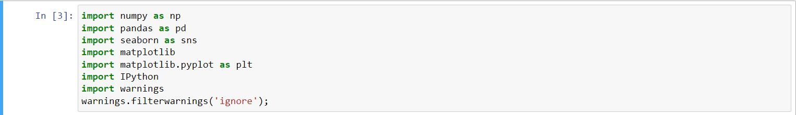

***Reading the csv files:***

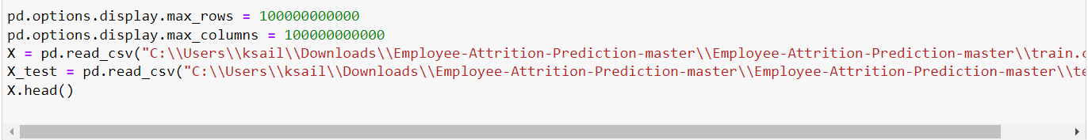

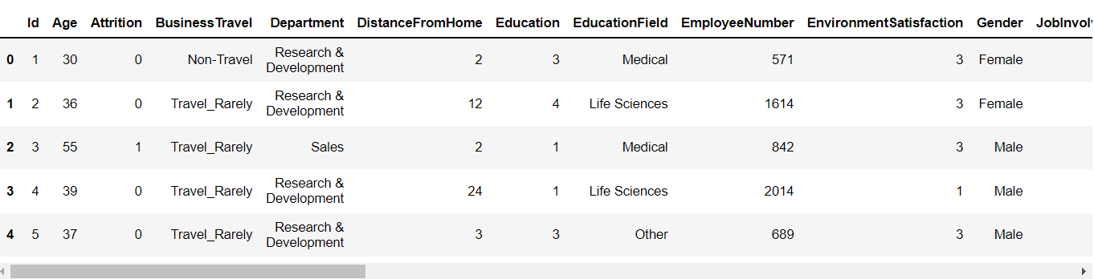

**

***Data Visualization:***

***Categorical Data:***

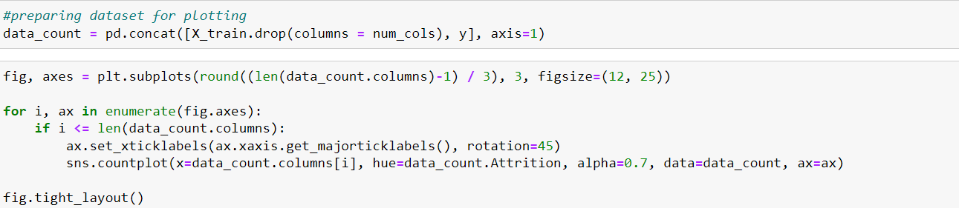

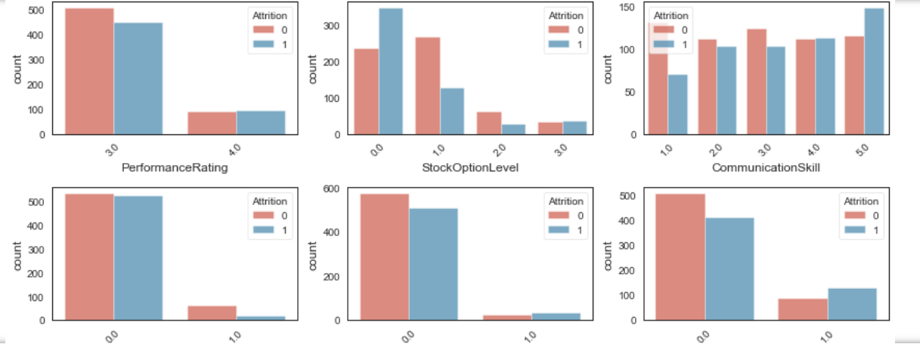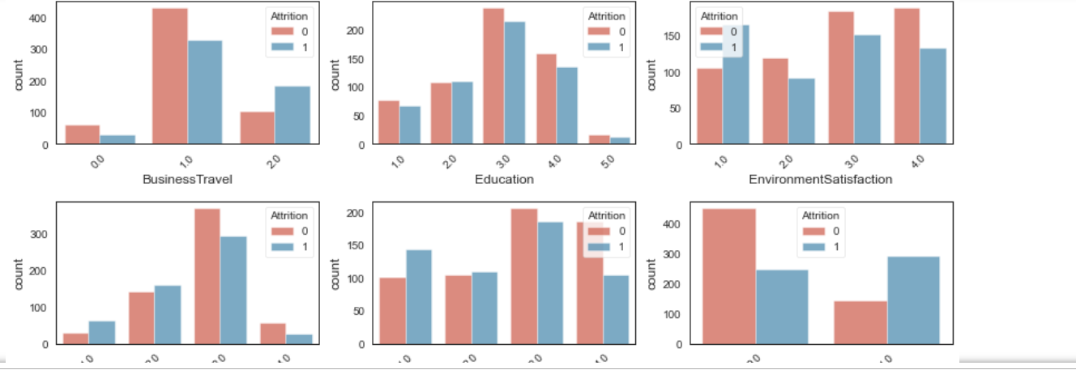

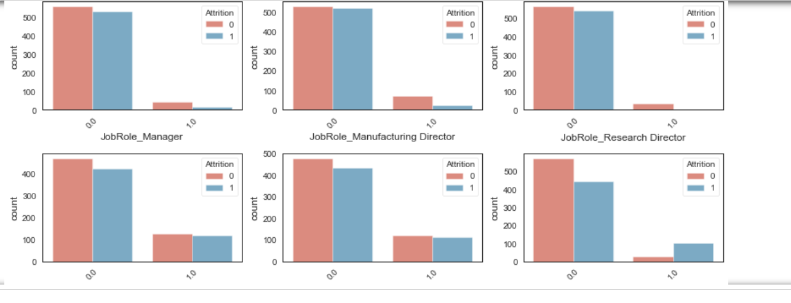

***Numerical Data:***

*X_train[num_cols].hist(figsize=(14,10),xlabelsize=8, ylabelsize=8);*

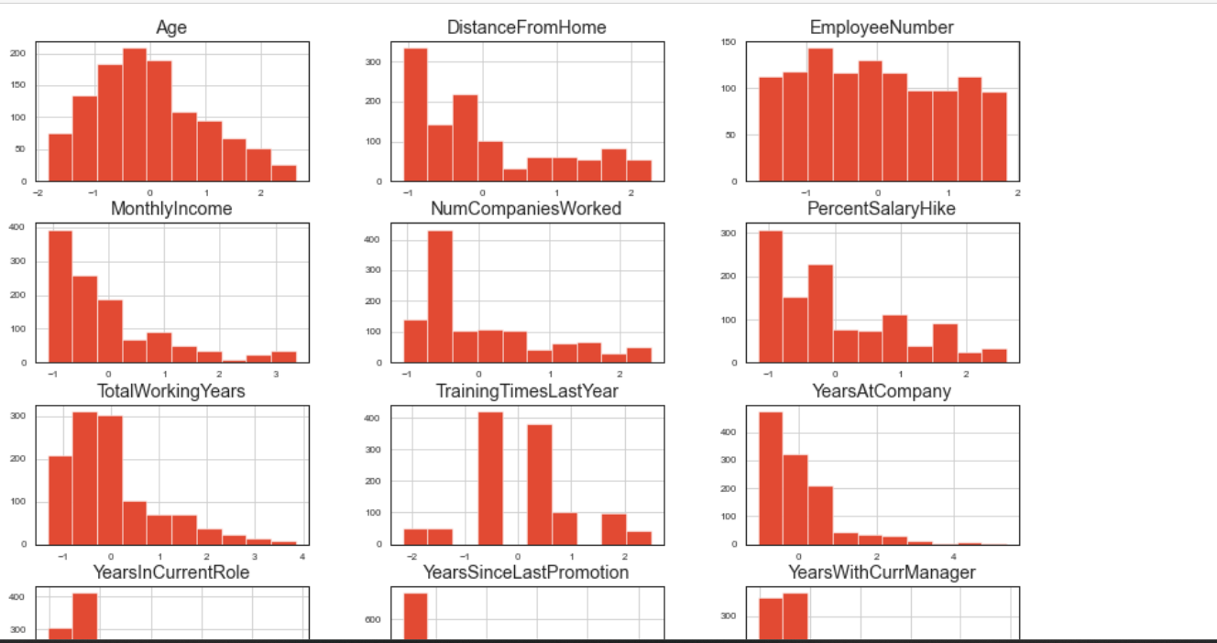

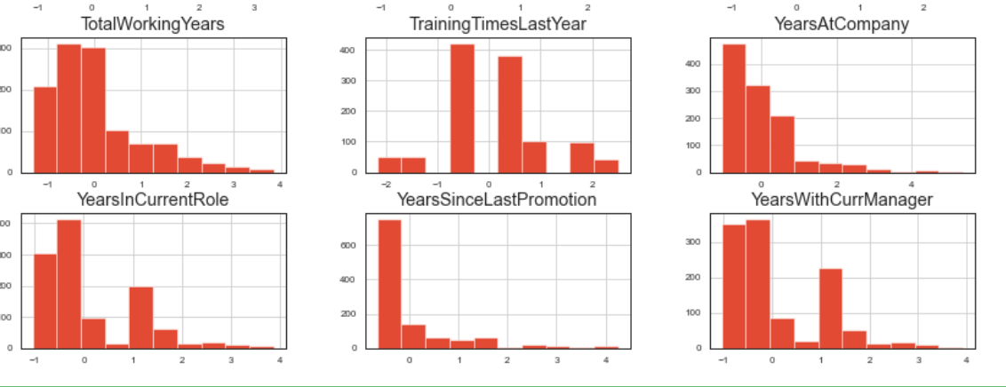

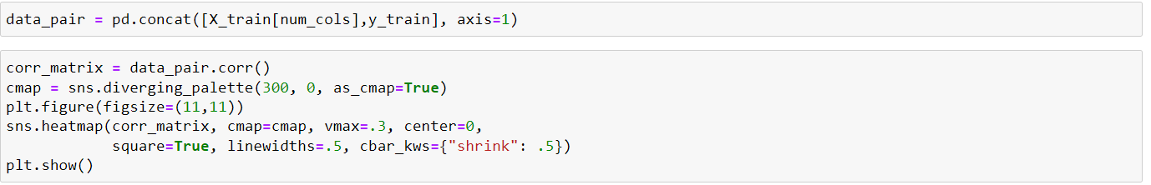

*HeatMap:*

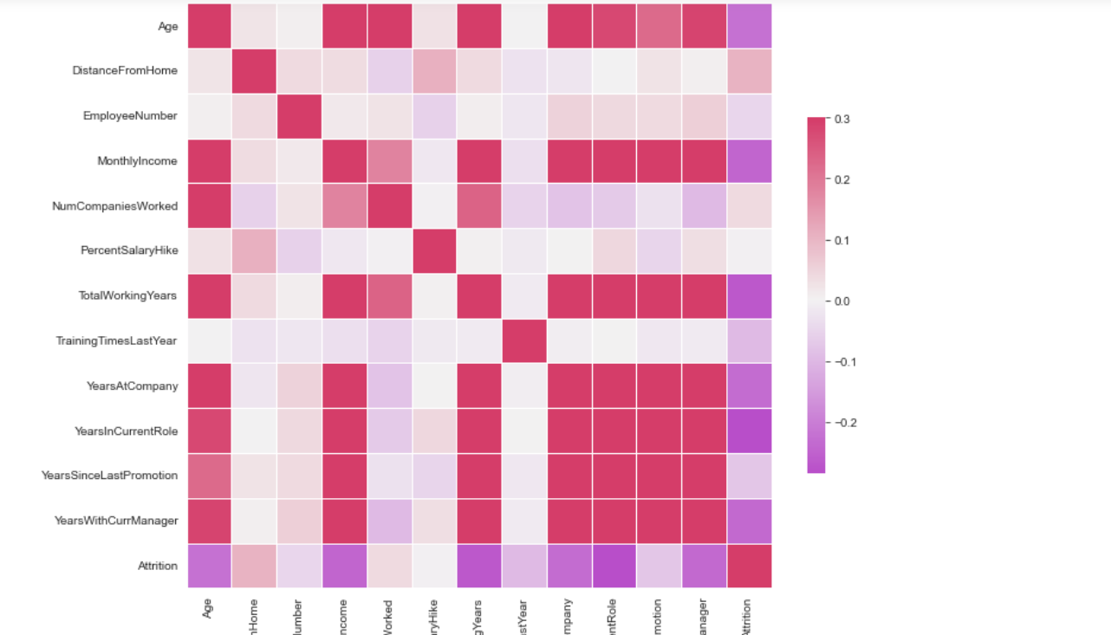

*Handling Skewed columns:*

